 | 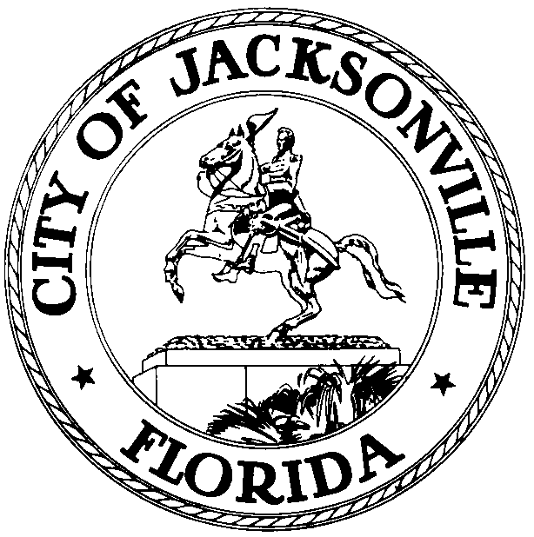
 | OFFICE OF THE CITY COUNCIL
Sam Newby  Council Member, At-Large Group 5 |  | 117 W Duval Street  City Hall, Suite 425
Office (904) 630-1387 |  | Jacksonville, FL 32202
Fax (904) 630-2906
E-Mail: snewby@coj.net

October 12, 2016
3:00 PM

TO: Public Health and Safety Committee Members
Honorable Council Member Bill Gulliford, Vice Chair
Honorable Council Member Aaron Bowman
Honorable Council Member Anna Lopez Brosche
Honorable Council Member Katrina Brown
Honorable Council Member Tommy Hazouri
Honorable Council Member Joyce Morgan

FROM: Sam Newby, Chair

SUBJECT: 2016-2017 Public Health and Safety Agenda Meeting Change of Location

Notice is hereby given that the PHS Chair, Sam Newby, will meet with the PHS Committee Members in the Council Chambers located at 117 W. Duval St., 1st Floor, St. James Building, at 8:30 AM prior to each regularly scheduled PHS Committee meeting. This location change is effective October 18, 2016 and for the remainder of the Council year. Please revise your calendars accordingly. As always, all interested parties are invited to attend. If you have any questions, please contact Tess Patterson, Legislative Assistant at 630-1404.

SN/tp

cc: Council Members/Staff
Cheryl Brown, Director/Council Secretary
Carol Owens, Chief, Legislative Services Division
Jeff Clements, Chief, Research
Kristi Sikes, Chief, Administrative Services Division
Council Auditor’s Office
Office of the General Counsel
CityC@coj.net
Posted Meeting - City Council Calendar
Electronic Notification - 1st Floor City Hall
Public Notice System - City Council Webpage
Media Box
File Copy

